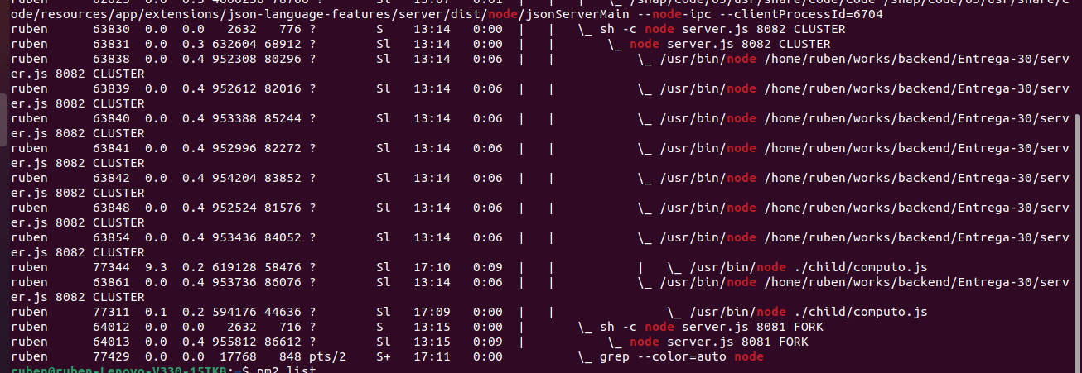
Procesos:

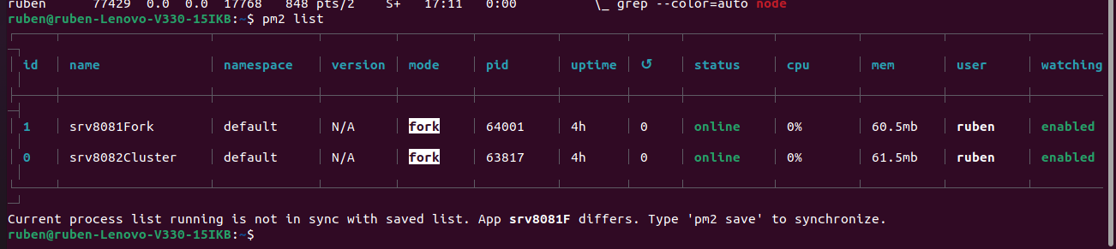

PM2 list

PROBANDO EL PROXY

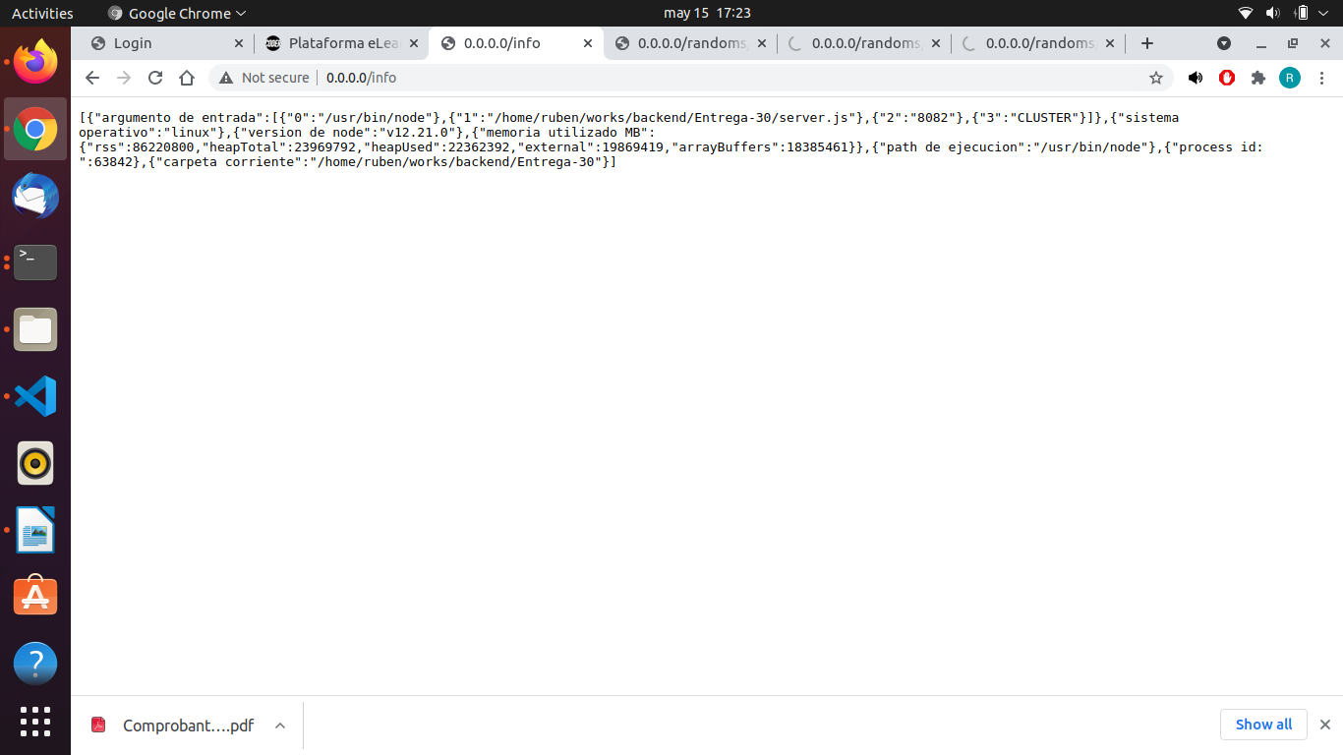

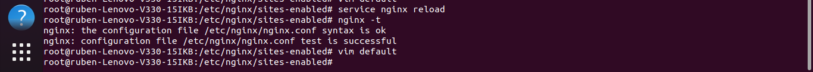
Configuración NGINX

upstream mi_node {
server 127.0.0.1:8081;
server 127.0.0.1:8082 weight=3;
}
server {
listen 80 default_server;
listen [::]:80 default_server;

root /var/www/html;

index index.html index.htm index.nginx-debian.html;

server_name nginx_node_;

location / {
proxy_pass http://mi_node/;

}

}

